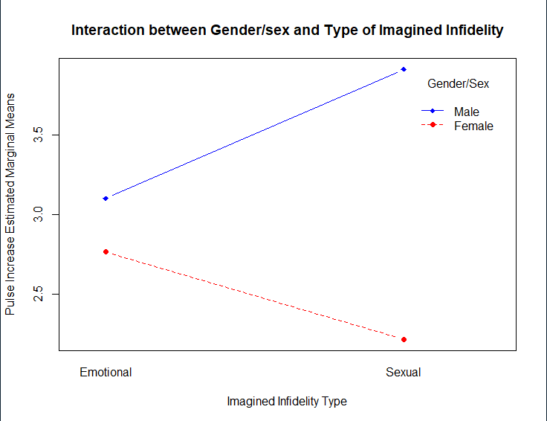

A 2 x 2 factorial ANOVA was employed to determine the effectsof gender/sex and type of imagined infidelity on participants’ amount of increase in heart rate.A .05 criterion of statistical significance was employed for all tests. **The main effects of age, F(1, 90) = 29.94, p<.001, η2= .090, 90% CI [.020, .187], and recall condition, F(4, 90) = 47.19, p< .001, η2= .568, 90% CI [.441, .633) were statistically significant, as was their interaction, F(4, 90) = 5.93, p< .001, η2= .071, 90% CI [.000, .132], MSE= 8.03 for each effect. Overall, younger participants recalled more items (M= 13.16) than did older participants (M= 10.06), d= .622, 95% CI [.219, 1.022]. As shown in the table below, recall was better for the conditions which involved greater depth of processing than for the conditions that involved less cognitive processing.**